WEARLAB COMPLETE WEBSITE CONTENT PLAN
1. Website Identity
Brand: WEARLAB
Instagram: @wearlab_official
Business type: Pakistani streetwear / casual fashion brand
Primary market: Pakistan
Currency: PKR
Brand positioning: Affordable, premium-looking, modern everyday streetwear.
Brand tagline options
- EVERYDAY, ELEVATED.
- Modern streetwear. Made for your everyday.

2. HEADER
Keep the navigation extremely clean.
Top announcement bar
FREE DELIVERY ON ORDERS ABOVE PKR 3,000
Main navigation
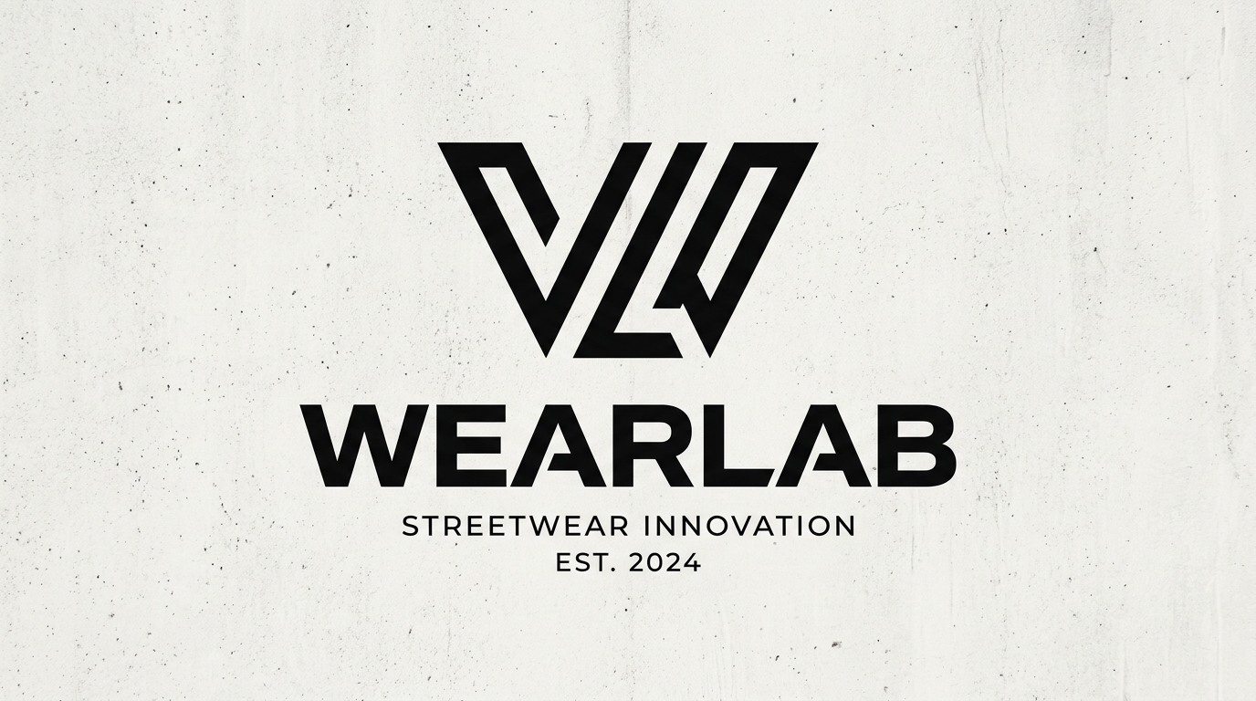
WEARLAB logo
- Home
- Shop
- New Arrivals
- T-Shirts
- Polos
- Drop Shoulders
- About
- Contact
Right side:
- 🔍 Search
- 👤 Account
- 🛒 Cart

3. HOMEPAGE
SECTION 1
Main heading
EVERYDAY, ELEVATED.
Subheading
Modern streetwear designed for everyday movement, expression and confidence.
Primary button
SHOP THE COLLECTION
Secondary button
EXPLORE NEW ARRIVALS

4. FEATURED COLLECTION
Small heading
THE LATEST DROP
Main heading
MADE FOR YOUR EVERYDAY.
Description
Discover our latest essentials — designed with clean silhouettes, modern details and the confidence to stand on their own.
Button
SHOP ALL
Display 3 products.

6. PRODUCT CARDS
Each product card should show:
Product image
Product name
Price
Available sizes

7. SHOP BY CATEGORY

Heading
FIND YOUR FIT.
Three large visual cards:
DROP SHOULDERS
Relaxed silhouettes. Statement energy.
SHOP DROP SHOULDERS →
POLOS
Clean. Versatile. Effortless.
SHOP POLOS →
T-SHIRTS
Everyday essentials, refined.
SHOP T-SHIRTS →

8. BRAND STATEMENT SECTION
Small heading
THE WEARLAB STANDARD
Main heading
LESS NOISE. MORE STYLE.
Text
WEARLAB was created for people who want their everyday clothes to feel like more than just basics.
We combine modern silhouettes, clean design and wearable details to create streetwear that feels confident without trying too hard.
Designed in Pakistan. Made for your everyday.
Button
OUR STORY

9. PRODUCT FEATURE SECTION
Heading
QUIETLY BOLD.
Text
Designed to stand out without shouting. Our pieces are built around clean aesthetics, comfortable fits and everyday versatility.
Button
SHOP WEARLAB

10. WHY WEARLAB?

QUALITY FIRST
Thoughtfully selected fabrics, construction and finishing.
MODERN FITS
Contemporary silhouettes designed for today's streetwear culture.
EVERYDAY WEAR
Pieces made to move from campus to city, day to night.
DESIGNED IN PAKISTAN
Local creativity with a modern global perspective.

12. INSTAGRAM SECTION
Heading
FOLLOW THE LAB.
Text
New drops. Behind the scenes. Fits. Stories.
Button
@WEARLAB_OFFICIAL

13. CUSTOMER REVIEWS
Once you have genuine customers:
Heading
Each review:
“Great fit and really good quality.”
— Verified Customer
You can eventually show:
⭐⭐⭐⭐⭐

14. EMAIL NEWSLETTER
Heading
JOIN THE LAB.
Text
Get first access to new drops, limited releases and WEARLAB updates.
Input:
Enter your email
Button:
JOIN US

15. HOMEPAGE FINAL CTA
Large minimalist section.
Heading
YOUR EVERYDAY FIT.
Text
Discover the latest from WEARLAB.
Button
SHOP NOW

16. SHOP PAGE
URL:
/collections/all
Heading
SHOP ALL
Subheading
Explore the latest WEARLAB collection.
Filters:
- Category
- Size
- Price
- Availability
Sorting:
- Featured
- Newest
- Price: Low to High
- Price: High to Low

17. DROP SHOULDERS PAGE
Heading
DROP SHOULDERS
Description
Relaxed fits. Modern silhouettes. Everyday attitude.
Products:
DROP SHOULDER RETRO
PKR 1,700
DROP SHOULDER VIBES
PKR 1,800

18. POLOS PAGE
Heading
POLOS
Description
A cleaner take on everyday streetwear.
Product:
WEARLAB POLO
PKR 1,550

20. PRODUCT PAGE
Use:
Product name
DROP SHOULDER RETRO
Price
PKR 1,700
Short description
A relaxed everyday built for modern streetwear. Clean, comfortable and designed to make an understated statement.
Size selector
SELECT SIZE
- S
- M
- L
- XL
Quantity
− 1 +
Button
ADD TO CART
Secondary:
BUY IT NOW

21. POLO PRODUCT PAGE
Product
WEARLAB POLO
Price
PKR 1,550
Description
A clean everyday polo designed to bring a refined edge to casual streetwear.
Button
ADD TO CART

22. CUSTOMIZATION PAGE
I strongly recommend making this a separate page.
URL:
/pages/customization
Hero heading
YOUR IDEA. YOUR DESIGN.
Subheading
Custom apparel made for teams, societies, businesses, events and individuals.
Services
CUSTOM PRINTING
Bring your artwork, logo or concept to life through high-quality apparel printing.
TEAM & EVENT APPAREL
Create coordinated apparel for university societies, organizations, teams and events.
CTA
REQUEST A CUSTOM ORDER

Custom order form
Fields:
Full Name
WhatsApp Number
Email
Organization / Team
Minimum Number of Pieces 30
Product Type
- T-Shirt
- Polo
- Drop Shoulder
Customization Type
- Printing
Design Upload
Required Delivery Date
Additional Details
Button:
SUBMIT REQUEST

23. ABOUT US PAGE
URL:
/pages/about
Heading
ABOUT WEARLAB
Main text
WEARLAB is a Pakistani streetwear and casual fashion brand built around a simple idea: everyday clothing should feel better, look better and say something about you.
We create modern, wearable pieces for a generation that values individuality, comfort and clean design.
From relaxed silhouettes to refined everyday essentials, every WEARLAB piece is designed with a focus on quality, style and versatility.
We are building WEARLAB from Pakistan with the ambition to create a brand that feels local in its roots and modern in its perspective.

Our vision
# OUR VISION
To build a modern Pakistani fashion brand recognized for its design, quality and everyday relevance.
Our mission
# OUR MISSION
To make well-designed, accessible streetwear that allows people to express their individuality with confidence.

24. CONTACT PAGE
CONTACT WEARLAB
Heading
LET'S TALK.
Text
Have a question about an order, product or custom project? We're here to help.
Contact options
Instagram
@wearlab_official

WhatsApp
0325-3310443
Contact form
Name
Email
Phone / WhatsApp
Subject
Message
Button:
SEND MESSAGE

25. FAQ PAGE
URL:
/pages/faq
Frequently Asked Questions
How can I place an order?
Select your product, choose your size and add it to your cart. Proceed to checkout and provide your delivery information.
Do you offer Cash on Delivery?
Yes, Cash on Delivery is available for eligible orders in Pakistan.
Only publish this once your payment system actually supports it.
How long does delivery take?
Orders are generally delivered within the estimated delivery window shown at checkout. Delivery times may vary depending on location and courier conditions.
Can I exchange my product?
Exchange eligibility depends on our Exchange & Return Policy.
Can I customize a product?
Yes. WEARLAB offers custom printing and embroidery services.
How do I choose my size?
Check our size guide available on each product page before placing your order.
How can I track my order?
Once your order is dispatched, tracking information will be shared through your selected contact channel.

27. SHIPPING POLICY
Heading
SHIPPING POLICY
Pakistan
We currently deliver across Pakistan through our courier partners.
Delivery time
Estimated delivery time: 3–5 business days after order confirmation.
Important
Delivery times may vary depending on destination, courier delays, weather conditions and other unforeseen circumstances.
Order information
Customers are responsible for providing a complete and accurate delivery address and an active contact number.
Tracking
Once your order is dispatched, tracking information will be shared with you.

28. EXCHANGE & RETURN POLICY
Heading
EXCHANGE & RETURN POLICY
Eligibility
Items must:
- Be unused
- Be unworn
- Be unwashed
- Have original tags attached
- Be in original packaging
- Be requested within 7 days of delivery
Exchanges may be accepted for:
- Wrong size
- Wrong product received
- Manufacturing defect
Not eligible
- Used products
- Washed products
- Damaged products caused by customer
- Customized products
- Products without original tags
- Sale items, if you choose to exclude them
Process
Contact WEARLAB through WhatsApp or Instagram with your order number, product details and clear photographs.
Then your team reviews the request.
Important: Don't publish a policy until you decide who pays return/exchange courier charges and what your exact procedure will be.

29. PAYMENT POLICY
Heading
PAYMENT POLICY
Possible methods:
Cash on Delivery
Bank Transfer
Online Payment

30. PRIVACY POLICY
/policies/privacy-policy
Information we collect
- Name
- Phone number
- Email
- Delivery address
- Order information
- Payment information where applicable
- Website usage information
How we use information
We use customer information to process orders, provide customer support, communicate order updates and improve our website and services.
Payment information
Payment information is processed through our selected payment providers. WEARLAB does not unnecessarily store sensitive payment information.
Marketing
If you subscribe to WEARLAB communications, we may send you updates about products, promotions and brand news. You may unsubscribe at any time.
Cookies
Our website may use cookies and similar technologies to improve functionality, understand website usage and provide a better shopping experience.
Third-party services
We may use third-party services such as payment gateways, courier services, analytics tools and website infrastructure providers to operate our business.
Contact
For privacy-related questions, contact WEARLAB through our official customer support channels.

31. TERMS & CONDITIONS
Create:
/policies/terms-of-service
Sections:
1. General
By using the WEARLAB website, you agree to these terms and conditions.
2. Products
We make reasonable efforts to display product information accurately. Product colors may vary slightly depending on screen settings.
3. Pricing
All prices are listed in Pakistani Rupees unless otherwise stated.
4. Orders
WEARLAB reserves the right to verify or cancel an order where necessary, including cases involving incorrect information or suspected fraudulent activity.
5. Payment
6. Delivery
Link to Shipping Policy.
7. Exchanges & Returns
Link to Exchange & Return Policy.
8. Intellectual Property
WEARLAB branding, logos, graphics, photographs, text and original content may not be reproduced or used without permission.
9. Website Usage
Users may not misuse the website or attempt to interfere with its operation.
10. Contact
Provide official customer-support information.

32. ORDER TRACKING PAGE
Very useful.
Heading
TRACK YOUR ORDER
Text
Enter your tracking number below to see your order status.
Input:
Enter tracking number
Button:
TRACK ORDER

33. CART
Heading
YOUR CART
Show:
Product
Size
Quantity
Price
Buttons
CONTINUE SHOPPING
PROCEED TO CHECKOUT
Small text:
Shipping charges calculated at checkout.

34. CHECKOUT
Required fields:
Delivery
- Email
- Phone / WhatsApp
- Full Name
- Address
- City
- Province
- Postal Code
PLACE ORDER

35. ORDER CONFIRMATION
Heading
ORDER CONFIRMED.
Text
Thank you for shopping with WEARLAB.
Your order has been received. We'll contact you with confirmation and delivery updates.
Buttons
TRACK ORDER
CONTINUE SHOPPING

36. FOOTER

Column 1
WEARLAB
Modern streetwear. Designed in Pakistan.
Column 2 — SHOP
- Shop All
- New Arrivals
- Drop Shoulders
- Polos
- T-Shirts
Column 3 — HELP
- Contact
- FAQ
- Size Guide
- Shipping
- Track Order
- Exchange & Returns
Column 4 — COMPANY
- About Us
- Customization
- Privacy Policy
- Terms & Conditions
Column 5 — FOLLOW
Instagram
Facebook
Newsletter
JOIN THE LAB.
Get first access to new drops and updates.
EMAIL
SUBSCRIBE
Bottom:
© 2026 WEARLAB. All rights reserved.
Designed in Pakistan.

39. PRODUCT DATA FOR CURRENT PRODUCTS
PRODUCT 01
DROP SHOULDER RETRO
Price: PKR 1,700
Short description:
A relaxed everyday silhouette designed for a clean, modern streetwear look.
Tags:
Drop Shoulder
Streetwear
Everyday
New Arrival

PRODUCT 02
DROP SHOULDER VIBES
Price: PKR 1,800
Short description:
A contemporary drop-shoulder silhouette made for effortless everyday style.
Tags:
Drop Shoulder
Streetwear
Everyday
New Arrival

PRODUCT 03
WEARLAB POLO
Price: PKR 1,550
Short description:
A refined everyday polo combining a clean silhouette with modern WEARLAB styling.
Tags:
Polo
Essentials
Everyday

40. SEO
Homepage SEO title
WEARLAB | Modern Pakistani Streetwear
Meta description
Discover WEARLAB — modern Pakistani streetwear designed for everyday wear. Shop drop shoulders, polos, T-shirts and customized apparel.

About SEO
WEARLAB | About Us
Learn about WEARLAB, a Pakistani streetwear brand creating modern, accessible and everyday fashion.

Shop SEO
Shop WEARLAB | Pakistani Streetwear
Shop WEARLAB's latest collection of modern streetwear, including drop shoulders, polos and everyday essentials.

41. 404 PAGE
Heading
LOST YOUR WAY?
Text
Looks like this page went somewhere else.
Button
BACK TO SHOP

42. SEARCH NO RESULTS
Heading
NOTHING FOUND.
Text
We couldn't find what you're looking for.
Button
SHOP ALL

43. BRAND VOICE
Every page should follow these rules:
WEARLAB sounds:
- Confident
- Minimal
- Modern
- Young
- Premium
- Direct

Instead:
NEW DROP. NOW LIVE.

